**Visvesvaraya Technological University**

# VTU-logoBelgaum, Karnataka-590 014

A Project Report on

**“Design and Analysis of an Electric Bike Chassis Frame”**

**Project Report submitted in partial fulfillment of the requirement for the**

**award of the degree of**

**Bachelor of Engineering in Mechanical Engineering**

**Submitted by**

**Himanshu Sharma 1DS14ME055**

**Prathik Kamath 1DS14ME060**

**Gaurav Kumar 1Ds14ME062**

**Rojin K John 1DS14ME117**

**Under the Guidance of**

**Prof. Kishore Kumar**

**Dept. of Mechanical Engg.,**

**DAYANANDA SAGAR COLLEGE OF ENGINEERING, Bangalore**



**Department of Mechanical Engineering**

**(Accredited by NBA)**

**DAYANANDA SAGAR COLLEGE OF ENGINEERING**

**SHAVIGE MALLESHWARA HILLS, KUMARSWAMY LAYOUT, BANGALORE-78**

**Accredited by National Assessment and Accreditation Council (NAAC) with ‘A’ grade**

**June 2018**

**DAYANANDA SAGAR COLLEGE OF ENGINEERING**

**SHAVIGE MALLESHWARA HILLS, KUMARSWAMY LAYOUT, BANGALORE-78**

**Accredited by National Assessment and Accreditation Council (NAAC) with ‘A’ grade**



**CERTIFICATE**

Certified that the project work entitled **“Design and analysis of an Electric Bike Chassis”** carried out by **Mr. Himanshu Sharma (1DS14ME055), Mr. Prathik Kamath (1DS14ME060), Mr. Gaurav Shukla (1DS14ME062) and Mr. Rojin K John (1DS14ME117)** bonafied students of DAYANANDA SAGAR COLLEGE OF ENGINEERING in partial fulfillment for the award of **Bachelor of Engineering** in Mechanical Engineering of the Visvesvaraya Technological University, Belgaum during the year 2018. It is certified that all corrections/suggestions indicated for Internal Assessment have been incorporated in the Report deposited in the departmental library. The project report has been approved as it satisfies the academic requirements in respect of Project work prescribed for the said Degree.

|  |  |  |
| --- | --- | --- |
| **Prof.**  **Kishore Kumar** | **Dr. R. Keshavamurthy**  **Prof. & HOD Dept. of ME** | **Dr. C.P.S. Prakash**  **Principal** |

External Viva

Examiner Signature with date:

1.

2.

**DECLARATION**

We, the students of final semester Mechanical Engineering, **Dayananda Sagar College of Engineering** declare that the work entitled "**Design and Analysis of an Electric Bike Chassis**" has been successfully completed under the guidance of **Mr. Kishore Kumar**, Department **of Mechanical Engineering, Dayananda Sagar College of Engineering, Bangalore**. This dissertation work is submitted to Visvesvaraya Technological University in partial fulfillment of the requirements for the award of Degree of **Bachelor of Engineering in Mechanical Engineering** during the academic year 2018. Further the matter embodied in the project report has not been submitted previously by anybody for the award of any degree or diploma to any university.

Place:

Date:

Team members:

1. Himanshu Sharma

2. Prathik Kamath

3. Gaurav Shukla

4. Rojin K John

**ABSTRACT**

With the increase in awareness of Carbon Footprint and Global warming, there has been a rise in demand for Sustainable Automotive Technology. One such technology is Electric vehicles. They are the future of transportation. Electric mobility has become an essential part of the energy transition, and will imply significant changes for vehicle manufacturers, governments, companies and individuals.  Electric vehicles are now in demand and are crossing various performance barriers on the way. The present boom in the Electrical Vehicle Industry was the reason for the decision to design and analyze an Electric Bike chassis. The report describes the entire process of designing from scratch to getting ready a stable and rigid vehicle frame. Adopting a design procedure used in Industries a Three-Dimensional chassis was modelled. This Iterative process was followed by various analysis of the chassis under various loads. In some cases, the reaction forces in boundary areas of some parts were used as external loads in other ones. Various analysis done included Static Linear Analysis, Nonlinear Analysis, Fatigue load analysis and Crash Test. The analysis yielded the maximum load the chassis can withstand without failing, the factor of safety for the structure and also the ability to withstand a crash in real life conditions. This resulted in a Chassis which could be rolled out commercially with minimal design changes and investment of time.

**ACKNOWLEDGEMETS**

The final outcome of this assignment required a lot of guidance and assistance from many people and we are fortunate to have got this all along the completion of my work. Everything we have done is only due to such direction. Their contributions are sincerely appreciated and gratefully acknowledged. However, we would like to express our deep appreciation and indebtedness particularly to the following:

We extend our gratitude to **Dr. C P S Prakash**, Principal, Dayananda Sagar College of Engineering, for this opportunity.

We thank the Head of the Department of Mechanical Engineering, **Dr. R. Keshavamurthy** for his support.

We would also like to thank **Mr. Kishore Kumar** for his unending support with all things necessary to see the completion of this assignment.

We would also like to thank all our friends, relatives and others who in one or another way shared their support, either morally or physically.

We Thank You.

# ACKNOWLEDGEMETS

The final outcome of this assignment required a lot of guidance and assistance from many people and we are fortunate to have got this all along the completion of my work. Everything we have done is only due to such direction. Their contributions are sincerely appreciated and gratefully acknowledged. However, we would like to express our deep appreciation and indebtedness particularly to the following:

We extend our gratitude to **Dr. C P S Prakash**, Principal, Dayananda Sagar College of Engineering, for this opportunity.

We thank the Head of the Department of Mechanical Engineering, **Dr. R. Keshavamurthy**

for his support.

We would also like to thank **Mr. Kishore Kumar** for his unending support with all things necessary to see the completion of this assignment.

We would also like to thank all our friends, relatives and others who in one or another way shared their support, either morally or physically.

We Thank You.

# Contents

CERTIFICATE 1

DECLARATION 2

ABSTRACT 3

ACKNOWLEDGEMETS 4

LIST OF FIGURES 7

LIST OF TABLES 9

NOTATIONS

CHAPTER 1: INTRODUCTION

* 1. Overview
  2. Problem Statement
  3. Objectives

CHAPTER 2: LITERATURE REVIEW

* 1. Paper
  2. Articles
  3. Book

CHAPTER 3: METHODOLOGY

CHAPTER 4: MISSION REQUIREMENTS

CHAPTER 5: CONCEPTUAL DESIGN

5.1 Preliminary Assumptions Made

* 1. Formulae Used
  2. Substitution

CHAPTER 6: PRELIMINARY DESIGN

CHAPTER 7: DETAILED DESIGN/MODELLING

CHAPTER 8: FATIGUE ANALYSIS

* 1. Methodology of CFD analysis 
     1. Pre – Processing
     2. Meshing
     3. Solution
     4. Post processing

CHAPTER 9: LINEAR STATIC ANALYSIS

* 1. Material Data
  2. Pre Processing
  3. Meshing
  4. Solution

CHAPTER 10: NON LINEAR(ELASTO-PLASTIC) ANALYSIS

10.1 Solution

CHAPTER 11: CRASH ANALYSIS 27

ADVANTAGES AND DISADVANTAGES 29

ADVANTAGES 29

DISADVANTAGES 29

FUTURE SCOPE 30

CONCLUSION 31

REFERENCES 32

# LIST OF FIGURES

# LIST OF TABLES

# NOTATIONS

# CHAPTER 1: INTRODUCTION

### Overview

The chassis frame forms the backbone of a vehicle; its principle function is to safely carry the maximum load for all designed operating conditions. Automotive chassis is the main carriage system of a vehicle. The chassis serves as a skeleton upon which parts like gearbox and engine are mounted. The two-wheeler chassis consists of a frame, suspension, wheels and brakes. The chassis is what truly sets the overall style of the two-wheeler. Commonly used material for two-wheeler chassis is steel which is heavy in weight or more accurately in density. There are various alternate materials like aluminum alloys, titanium, carbon fiber, magnesium, etc.

With this project we attempt to design an entirely new chassis design concept which can be used in an Electric Bike subjected to various loading conditions like static and dynamic loadings on the chassis and the design is optimized by reducing the weight of the chassis by using alternate material and geometries while maintaining the strength.

We look forward to adhere to the spirit of design and create a stable, working and ready to manufacture bike chassis by various analysis, good engineering concepts and techniques.

**1.2 Problem Statement**

To Design and perform CAE analysis on an Electric Bike Chassis Frame.

### 1.3 Objective

In order to create an efficient design, one needs to

* Identify the needs and define the problem statement which in this case is to Design an Efficient Electric Bike Chassis.
* Research the problem which includes understanding the need for chassis, the best material to use, best geometries etc. required to create a stable chassis.
* Plan and design by selecting a promising solution obtained by various manual calculations and data collected during the research.
* Testing and optimization of the design under various loads and physical conditions.
* Improving the design in order to overcome various faults and shortcomings of the design based on the test phase.

**CHAPTER 2: LITERATURE SURVEY**

**2.1 Paper**

* **Static and Dynamic properties of a motorcycle frame**M. Bocciolone, F. Cheli, M. Pezzola & R. Viganò Department of Mechanical Engineering, Politecnico di Milano

**[**This paper provided an overview of a chassis for the future motorcycle. It provided us with purpose loads and safety factors used in structural analysis.]

* **Shape And Material Optimization Of A Two Wheeler Front Suspension Frame For Pipe Type And Rectangular Cross Sections**

T. Kondaiah, D.Pavan Kumar ,Department of Mechanical Engineering, PBR Vits, Kavali, India

[This paper provided insights into 3D modelling of suspension frames for various types of cross sections]

* **Modelling And Structural Analysis Of Two Wheeler Frame**

Ajay Katiyar, Anuj Prakash S C. Jayswal, Department of Mechanical Engineering, Indian Institute of Technology, Hauz Khas, Delhi, India

[This paper provided insight on material, design optimization, geometrical construction, assemblies and complex loading conditions. It also helped us in understanding weight reduction and design simulation]

**2.2 Book**

* **“Motorcycle Handling and Chassis Design, the art and science” by Tony Foale**

[This book helped us understand the complicated structure of a motorcycle which has long defied full analysis. Various types of loads, suspensions, chassis type etc. were few valuable bits of knowledge gained from this.]

# CHAPTER 3: METHODOLOGY

**Methods**

* Initial layout of chassis through ergonomics and reverse engineering using 3D CAD modeling.
* Comparing the bending ,torsional & longitudinal stiffness with the standards and updating the chassis frame to the required stiffness using the strength of materials and through numerical approximations using FEA.
* Performing the crash analysis and structural analysis to meet up with the road safety norms & updating the chassis depending on these results.

**Methodology**

* Seating positions are derived from reverse engineering techniques. CAD modeling is done on CATIA & Unigraphix.
* Preprocessing is done in hypermesh by using shell 181p element for 2d meshing. Maintaining different mesh style for crash and durability mesh.
* Elasto plastic analysis is done for localized high stress regions after neuberization by using multilinear kinematic data. Fatigue life is estimated for these regions and design is updated for high cycle fatigue life. Vibrational analysis is done by considering the vibrations forced on the chassis through the motor and the belt along with the vibration coming due to tires.
* Finally crash analysis is done through Explicit Dynamics to meet up with the road safety norms and chassis design is updated.

# CHAPTER 4: MISSION REQUIREMENTS

* To lay a groundwork and research about various types of chassis.
* Figure out how different an Electric Vehicle chassis is when compared to the Fuel Operated ones.
* Choose and Design an optimum chassis.
* Undertake different types of Analysis on the chassis to make it industry ready.
  + Crash Analysis
  + Nonlinear Analysis
  + Structural Analysis
  + Fatigue Analysis

# 

# CHAPTER 5: CONCEPTUAL DESIGN

### Preliminary Assumptions

### Material properties are isotropic.

### Swing arm is modelled just give the real time approximation in the assembly by giving proper location for supports.

### Spring element is used to simplify the modelling without using damping properties as dynamic loading is not considered.

### One node is fixed in the handle bar bearing to avoid solver pivotal error.

# 

# 

# This is the bounding box around which the space frame was built.

# CHAPTER 6: FINAL DESIGN

After thorough research work and considering various factors like cost, stability and feasibility, a final chassis was designed and all the tests and analysis are done on the same.

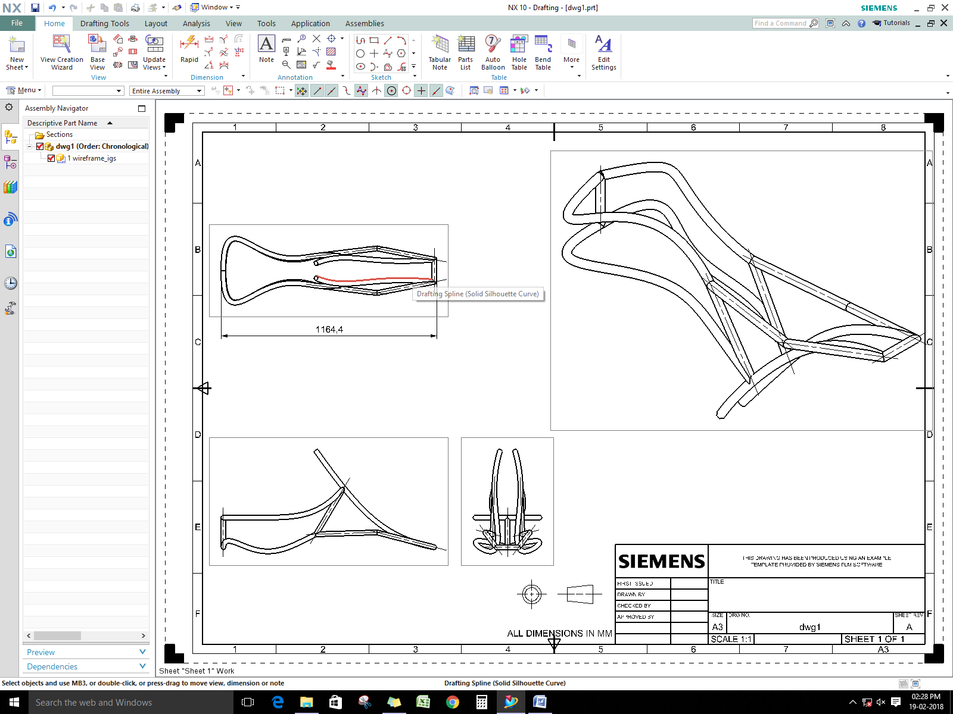

FIGURE final design of chassis frame

# CHAPTER 7: NEED FOR FINITE ELEMENT ANALYSIS

# 

Assuming Analytical Method approach gives answer very close to 100 and time taken = 1 month and Finite Element Analysis with reasonable mesh gives answers 90 within 1 days. In industry getting fast solution with logical or reasonable accuracy is more important than absolute accuracy.

**Advantages of FEA**

> Visualization

> Design Cycle Time

> No. of prototypes

> Testing

> Optimum design

**Visualization of results:**

For simple geometries such as simply supported beam or cantilever beam it is easy to point of maximum stress and displacement. But in real life parts or assemble with complex geometrical shapes made up of different material with many discontinuous subjected to flexible constraints complex loading varying with respect of time and point of application , further complicated by residual stresses joints like spot and arc wielding etc. it is not easy to locate failure location. But with the tool like (CAD/CAE) if modelled in proper fashion, one can easily get stress contour plots clearly indicating location of high stress.

**7.1 While starting any finite element analysis**

**1-D element:** Used for geometries of the dimension very large in comparison to rest of the two.

**2-D element:** Used when two of the dimension are very large in comparison to third one.

**3-D element:** Used when all the three are comparable.

**7.1.1 CHOOSING THE TYPE OF ELEMENT**

The type of element used for the analysis plays a major role in obtaining accurate results. Element type selection is based on

Element Type Selection

Geometry size Type of Analysis Time   
and shape

COMPARISON OF QUAD AND TRIANGLUAR ELEMENT



VS

* Quad element is more accurate than triangle element.
* Tri element is stiffer than equal quad, result is lesser stress & displacement if used in critical locations.
* Consider any standard problem of plate vibration for which analytical answer of natural frequency is known.

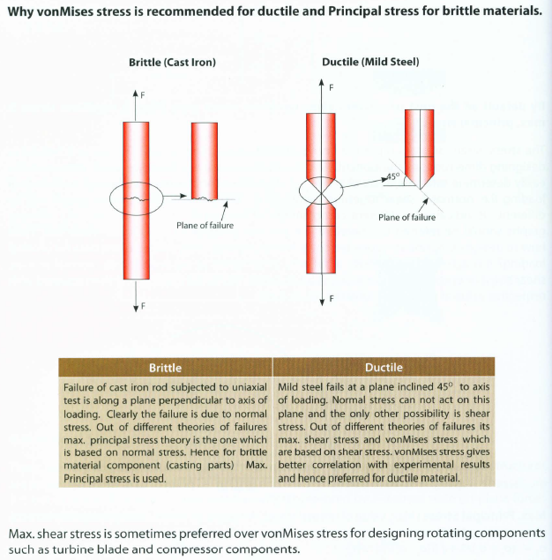

# CHAPTER 8: FATIGUE ANALYSIS

# WHY FATIGUE ANALYSIS?

* Fatigue accounts for 90% of service failures.
* Manufacture gives warranty on the components. Static and Dynamic analysis can give us about the stress, displacement etc
* Many times static or dynamic analysis predict location of failure not matching with lab test or field and then analysis keep on thinking whether something is wrong with boundaries.
* Failure or crack usually initiates at surface.

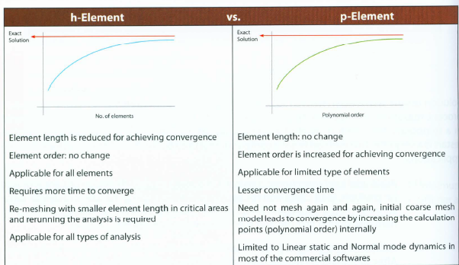

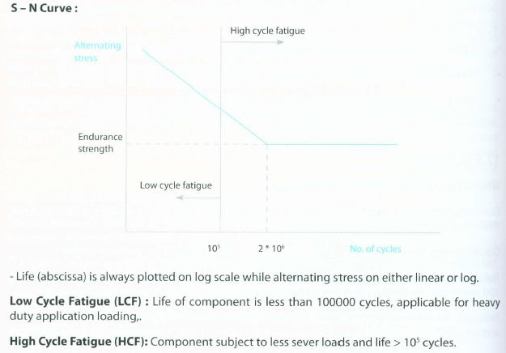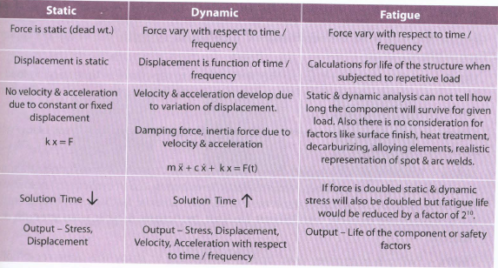

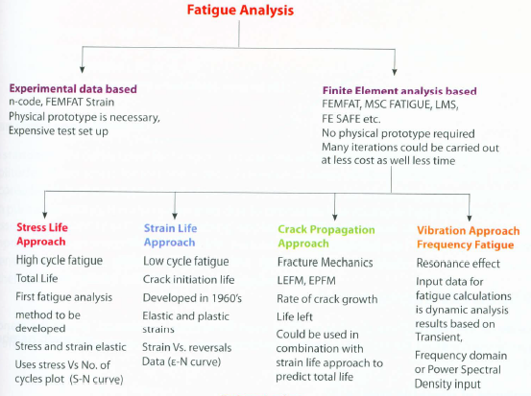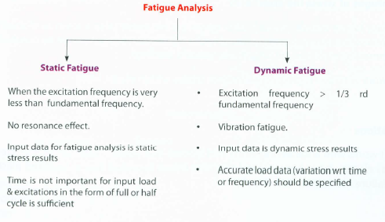

# 

# Figure chassis with loads and Boundary conditions applied

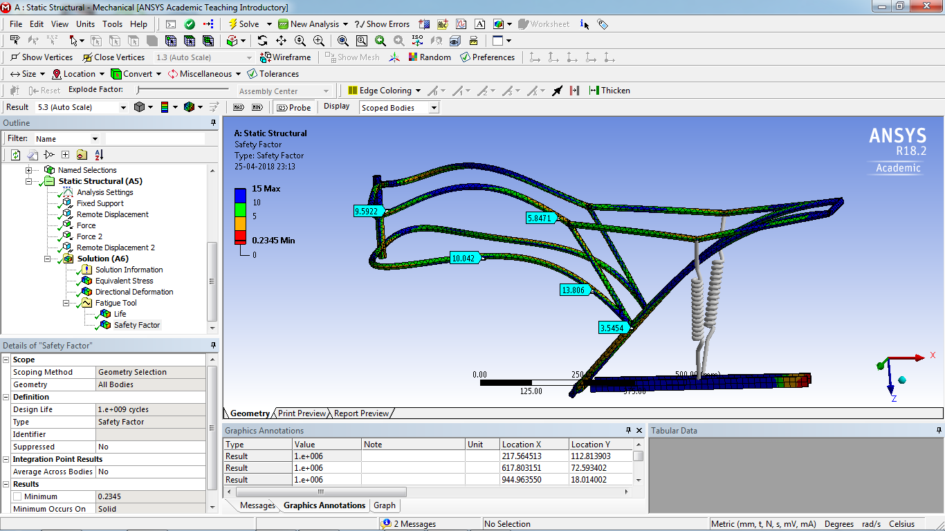**Safety Factor**

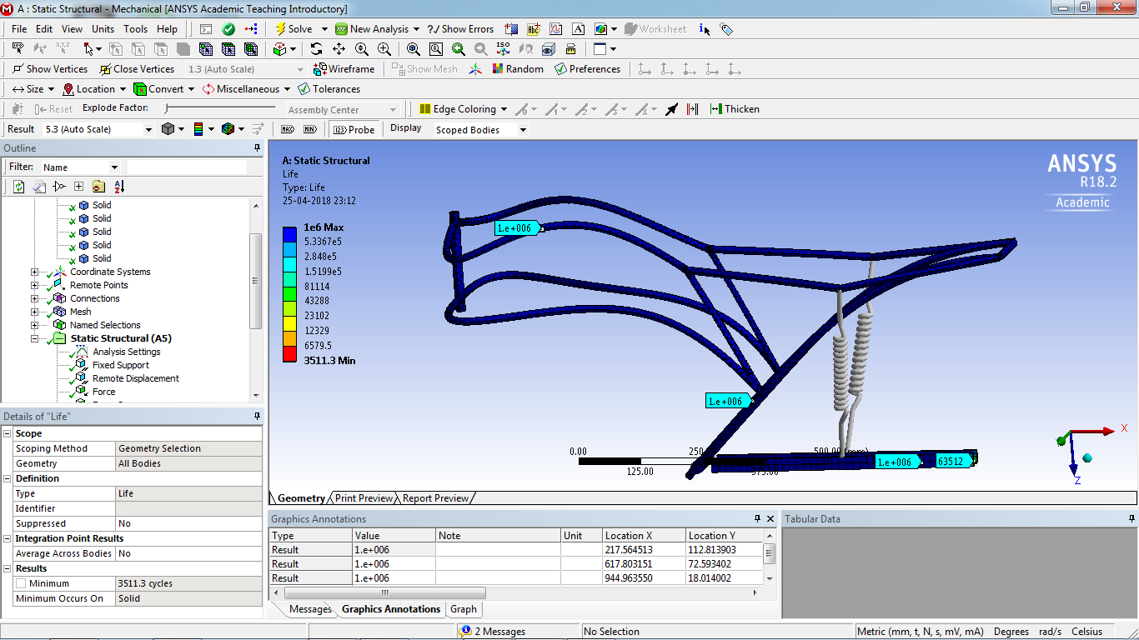**Life**

# CHAPTER 9: STATIC LINEAR ANALYSIS

### Material Data

From the properties obtained from different materials the finalized material is aluminium 6061 t6 grade metal for the chassis.

Following are the key properties for the finalization:

* T6 temper 6061 has an ultimate tensile strength of at least 290 MPa (42,000 psi) and yield strength of at least 240 MPa (35,000 psi).
* Aluminium 6061 t6 has one-third the density and one-third the modulus of steel – the diameter of the aluminium bar needs to be larger by 32 per cent, at which its weight will be only 58 per cent of that of the steel bar.
* Cost is comparably low.
* 6061 is highly weldable, for example using [tungsten inert gas welding](https://en.wikipedia.org/wiki/Tungsten_inert_gas_welding) (TIG) or [metal inert gas welding](https://en.wikipedia.org/wiki/Metal_inert_gas_welding) (MIG).
* 6061 has good fatigue behavior with fatigue strength of 125 mpa.

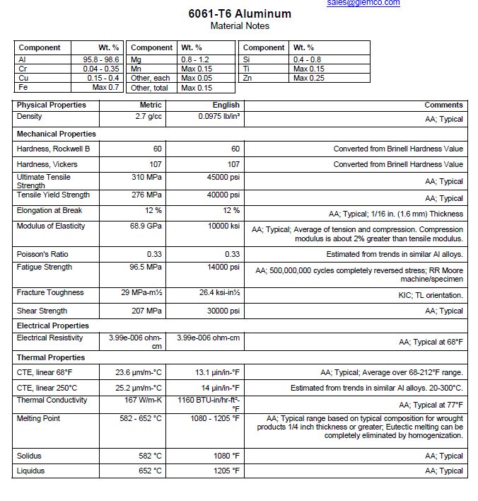

### Pre Processing

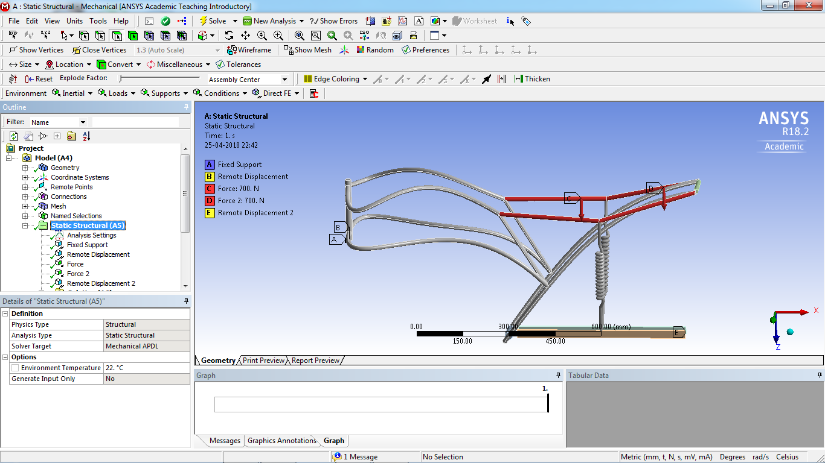

Figure chassis with loads and Boundary conditions applied

### Meshing

Meshing is the discretization of a model into small elements containing nodes for detailed analysis. ANSYS Fluent can use meshes comprised of triangular or quadrilateral cells (or a combination of the two) in 2D, and tetrahedral, hexahedral, polyhedral, pyramid, or wedge cells (or a combination of these) in 3D. The choice of which mesh type to use will depend on your application. When choosing mesh type, consider the following issues:

* + - setup time
    - computational expense
    - numerical diffusion

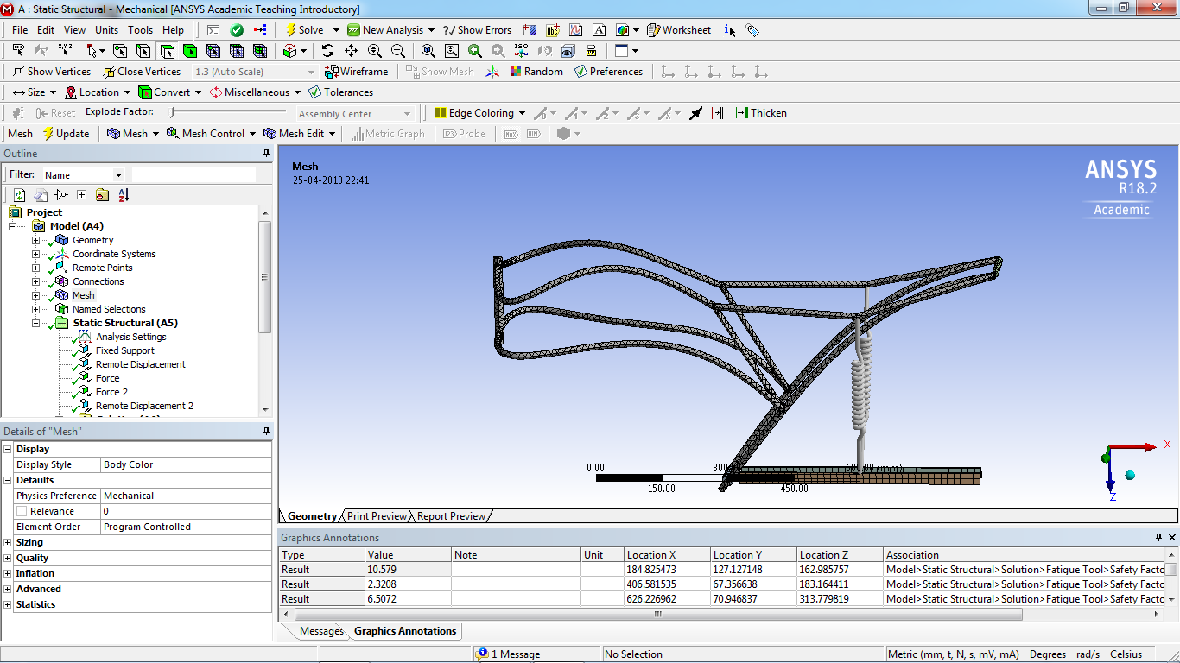

Figure Meshed chassis Section

### Solution

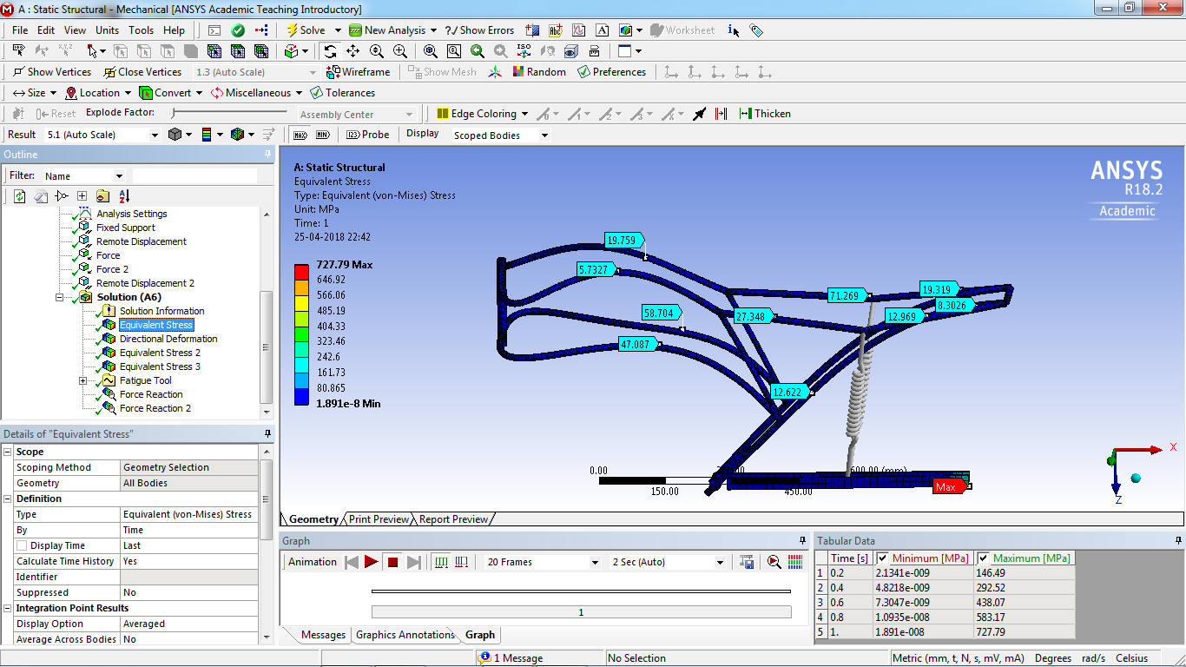

# CHAPTER10: NON LINEAR (ELASTO- PLASTIC)ANALYSIS

# INTRODUCTION

FINITE ELEMENT ANALYSIS(FEA) has become an integral part of design process in automobile aviation, civil aviation, and various consumer and industrial good industry. Cut throat competition in the Market puts in the tremendous pressure in the cooperation to launch reasonable priced product in the short time.

It is very important for the (FEA) result consumer to understand that there is no absolute result in given problem will vary depending upon several variable such as size and quality of the (FINITE ELEMENT) model material properties input to the material properties. If FE model are not built to correctly present.

FE analysis helps in accelerating design and development of product by minimizing number of physical test.

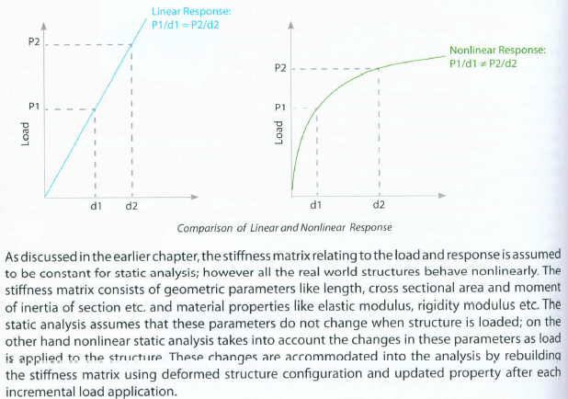IN this chapter we will discuss the practical aspects of nonlinear static. Then the analysis of such structure is know as linear analysis. When the load is to response relationship is not linear proportional then the analysis falls under the nonlinear analysis. But most of the time either material behavior is not linear in the operating condition or geometry of the survey to it form structure itself keeps it form responding linearly.

# A GENERAL PROCEDURE FOR NONLINEAR STATIC ANALYSIS PROJECT

# 

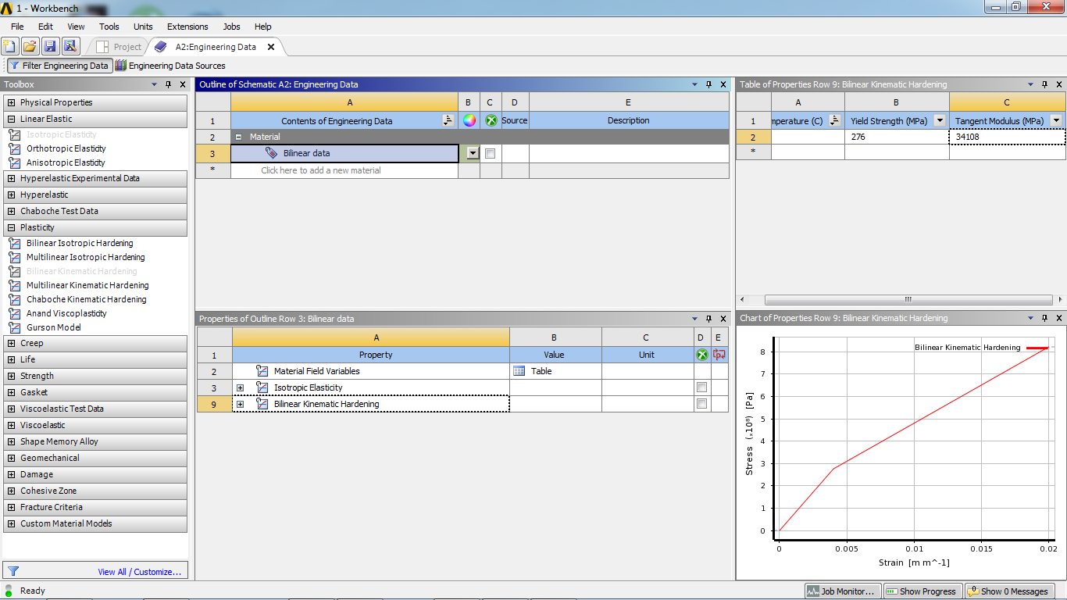A typical nonlinear static analysis, irrespective of what kind of analysis to be performed. Selection of appropriate element for certain application has already been discussed in earlier chapter. The FEA group is provided with past surface data, which is required to be meshed with element to get the component mesh. When all the parts in the assembly are meshed they are all component mesh. When all the parts in the assembly are meshed with element to get the component mesh. When all the parts in the assembly are meshed they all are all together using appropriate fastening elements. In the general, Quad and Hex element should be captured in the model appropriate. If there are fastening or welds between two parallel surface, attempts should be made to create similar mesh on both surface, this will facilitates placement of welds or rigid element normal to the surface without distorting the shell element. The stiffness and preloading should be defined for those element.

# Specific nonlinear analysis control parameters:

The basic controlling parameter for nonlinear static analysis are initial increment, minimum and maximum increment, maximum number ofiteration, the interval at which results file are to be output and convergence criteria for iteration.

# Run for analysis:

The FE model is now ready to be run. The analysis is run command may have option to specific solver version, memory size and number of CPUs to better control execution.

### 

### 

### Figure Meshed chassis Section

### Figure Loading and boundary conditions

### 

### Figure settings for non-linear control

### Figure Result

### 

# CHAPTER 11: CRASH ANALYSIS

# INTRODUCTION

Past few decades have seen in increasing application of CAE for simulation of crash phenomenon particularly due to the development of high computing machine and parallel computing techniques. The increase in safely standards can be attributed to the improvement of structural performance through Finite Element Analysis.

The effect of crash and impacts on structure is one problem and second one which is of prime importance is the safely occupants. We find that occupant safety simulation offers today reasonably accurate results which can save a lot of time and overall design cycle time. Today’s dummies have closer dynamics properties and also include the correct load carrying capacity to allow the interaction between the structure as compare to early dummies which didn’t take into account load entering into the body. The CAE development for these application was delayed due to unavailability of high and computing power and it can be said that such simulation are barely 20 years old. Although there has been a tremendous increase in the software to solve the problem related to automobile industry.

# TRANSIENT DYNAMICS SOLUTION METHODOLOGY

When solving dynamic problem with finite element method, it must be remembered that we have FEM only for the spatial discretization and the temporal time is always by using the finite element method .the equilibrium equation is solved and value of the unknown are determined at (t + delta t) Based on the knowledge of their values at g time (t).

Explicit methods are those in which the information at time step n+1 can be obtained in terms of previous time step and there is no dependence on the current time step.

# INCREASING THE SPEED OF EXPLICIT METHODS FOR QUASISTICS SIMULATION

In static we totally ignore the dynamic effect due to dynamic effect due to inertial force. The major difficult in using a dynamic code for getting a static simulation results are:

1: Presence of acceleration force term. Displacement are derived from solution of acceleration . Whereas in static, displacement are primary variable and are directly obtained.

2: Static stress analysis give you stress but dynamic code give you rather stress waves . the effects stress waves reflection at boundaries are always present in a dynamic solution .

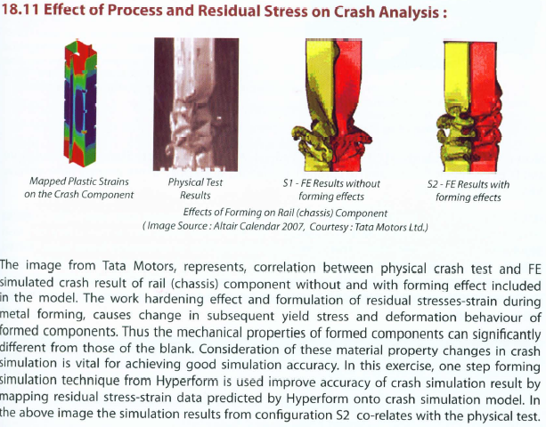

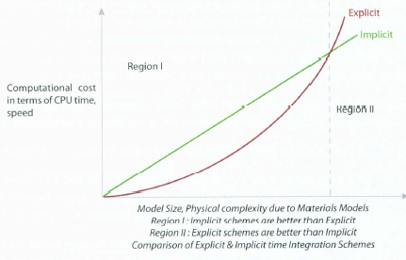

**Some points to note while running a dynamic simulation**

1. Always mention the system of unit which you would used for simulation.
2. You must have a fairly good idea of what be the total file size that the output as otherwise if your is wrong wrt generation of too much output of ascii and binary files, you will run out of space very soon
3. a thumb rule to remember is: if T is the temperature time, then your binary output file generation time step should be T/10 AND the ascii file size should be a further ten times lesser as you would require an accurate representation of energy.
4. There should be a zero penetration in the model so that there are no initial contact required energies in the model.
5. It is better to set the global element length to 5mm which corresponds to a time step of 1 e-06 sec. Try to make your initial runs with coarse mesh so that you know how your model behaves.
6. Usually a crash simulation software has different cards suitable for rigid bodies and deformable bodies. Carefully study these option so that you get a full idea of the capabilities of the software.
7. Try to use restarts to the maximum extent as this is a powerfully utility associated with explicit dynamic code.
8. Always check the CAE results with some hand calculation and make a note if some sense.
9. By using reduced integration you save a lot of computational time which is always necessary in transient dynamics.
10. There can be many errors and mistake by a beginner always remember that the cause of the errors is very much present in the deck itself. Common are wrongly formatted input, initial contact penetration.
11. If the time step is too small due to the present of small element it is always better to coarsen the mesh thus allowing an considerable increase in the time step.
12. Total energy of the system is always constant.

**Total Energy = Internal energy+ Kinetic energy+ External**

### 

Figure chassis with loads and Boundary conditions applied

### 

### Figure Deformed model

### 

### Figure Energy Summary

### ADVANTAGES AND DISADVANTAGES

### ADVANTAGES

* + - Economical
    - Sturdy Model

### DISADVANTAGES

# FUTURE SCOPE

# 

# CONCLUSION

* The chassis design in static analyses shows a working stress of 110Mpa well within the yield point, but we can scale the number *2 for conversion of dynamic loads to static loads & still having a FOS of 1.26
* Exact numbers of stress values are obtained in non linear analysis just to be on the conservative side just in case of geometric non linarites like stress stiffening.
* The designed chassis can survive in high cycle fatigue thus infinite life.
* The deformations of the chassis with frontal impact test at different speeds shows that the critical part i.e. the location of the battery is not disturbed.

# REFERENCES

[1] - [www.iosrjournals.org/iosr-jmce/papers/vol11-issue4/Version-3/J011435659.pdf](http://www.iosrjournals.org/iosr-jmce/papers/vol11-issue4/Version-3/J011435659.pdf)

[2] – http://www.capalex.co.uk/standards/round_tubes.html

[3] – <https://www.motorcyclistonline.com/ducati-desmosedici-rr-85-percent-solution>

[4] - <http://doras.dcu.ie/19502/1/Ping_Hwa_20130725155530.pdf>

[5]– http://www.amesweb.info/Materials/Aluminum-6061-Properties.aspx

[6] - https://www.makeitfrom.com/material-properties/SAE-AISI-4130-SCM430-1.7218-25CrMo4-G41300-Cr-Mo-Steel